Whitetail Deer Presentation
Cameron County Outdoor Youth Activities
in conjunction with the North Central Whitetails Chapter of Quality Deer Management Assoc. welcome
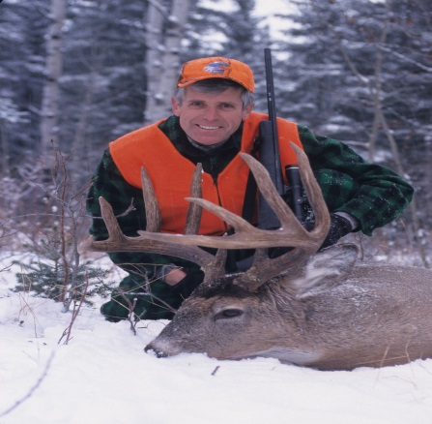

Families are invited to attend an enjoyable presentation on Whitetail deer by Charlie Alsheimer in Cameron County. There will also be educational booths set up.
Where: Cameron County High School Auditorium
When: September 21st 2013
Time: 7:00PM - Presentation
Cost: $5.00 adult $3.00 student
DOORS OPEN 5:30PM
Charles Alsheimer is an award winning outdoor writer, nature photographer, lecturer, and whitetail deer expert from Bath, NY. He is senior editor for Deer and Deer Hunting Magazine and co-host on their national TV show, Deer Hunting TV, which airs on NBC Sports Network.
Booths to see: Charlie Alsheimer, North Central Whitetails Chapter QDMA, Cameron County Long Beards NWTF, Outdoor Club and Cameron County Outdoor Youth Activities
Refreshments will be available.
ALL PROCEEDS WILL GO TOWARDS CAMERON COUNTY HIGH SCHOOL OUTDOOR CLUB!!!!!!

