Needed! Wildlife Botanists!
By John Dzemyan September 2020
(This article printed in the Keystone Wardens Magazine, Spring/Summer 2020 issue)
In my earlier years with the Pennsylvania Game Commission I met many people, young and old, who expressed a desire to have a job working with wildlife. They would tell me how nice it would be to work outside every day in the woods or wilds someplace protecting or studying some beautiful wild creature like a deer, bear, rabbit, songbird, etc.
They imagined trapping deer or bear or elk, otters or bobcats, eagles or turkeys or warblers, etc. Maybe radio collaring them and tracking their movements and learning all about them. Or they imagined stopping poachers from illegally killing deer or eagles or any of the hundreds of species of wildlife.
I would say to them that job sounds great to me also, and that “I’d like to have one like that”. Having worked many years in wildlife protection, wildlife education, and wildlife habitat management I knew that there was an enormous amount of time spent not outside, but inside a vehicle traveling someplace, and inside a room with a computer, typewriters and reams of paperwork that needed done on all sorts or wildlife related matters. Or at meetings with all kinds of people and organizations, etc.
As the years went by the realization sunk in more and more that one of the most important aspects about wildlife protection and management was not only knowing everything possible about the wild animals themselves, but just as important was to know everything possible thing about the plants that the wildlife lived and thrived in.
No matter how much you knew about an animal, how long it lives, how big it gets, how many teeth it has, how many young it produces, how far it travels, how to catch it and tag it and release and so forth. No matter if you had all that information and more, that animal needed the proper habitat to live in, which means, it needs the correct plants on the landscape for it to survive. I realized that not knowing the plants was a deficiency for maintaining these animals we enjoy so much. I also met lots of hunters, really good hunters, who could out hunt, out fish and out trap me every day of the year. They could find the best spots to stand in the woods and harvest a nice buck or a doe, or a turkey or a bear, and do it year after year. Yet when it came to understanding why a wildlife population went up or down, or especially why a deer population was not as plentiful as they desired, they, like me and many others, lacked the knowledge of what good habitat for deer and other wildlife was and is.
The simple answers that so many believed for so long were only part of the information one needed to manage or maintain abundant wildlife populations. Deer of course, make the best example for us to understand this dilemma about understanding and accepting good wildlife management.
For decades hunters and wildlife managers focused on how many deer, especially does, were harvested each year as if that were the only thing that mattered about how to have lots of deer. There were a few hunters and wildlife managers who spoke of what plants deer needed for habitat, but they were barely heard during conversations and discussions about deer populations. The overriding concern was how many doe licenses were to be sold, how many doe were to be harvested. The goal was to harvest only enough to keep the population from declining so that the next season the same or more deer would be available for the hunting seasons. Information about habitat and what it could support was out there, but few saw it with their own eyes or heard about it in a way they could understand. Even when some wildlife biologists went to great lengths at trying to inform hunters about the need to control deer so that the plants deer needed could survive, the botany aspect of wildlife management oftentimes got little coverage or attention.
In Penn’s Woods, as the age, the species compositions, the quantity and quality of plants changes on a given parcel of land, so does its ability to support wildlife of certain species and in certain populations. If one keeps the harvest rates the same in an attempt to keep the wildlife population at the same or higher levels year after year after year, and does not adjust them to the changing habitat conditions (the changes in plants on the landscape) and what those conditions can support, problems occur.
I am by no mean a botanist nor a biologist. I barely consider myself an amateur at best when it comes to plant identification. However, that does not diminish the importance of knowing the native plants of Pennsylvania and their importance to wildlife. And in no way do I want to diminish the importance of being a wildlife biologist. We need wildlife biologists just as much as we need game wardens just as much as we need to secretaries and dispatchers and many other job classifications that comprise the work of the Pa. Game Commission. We also need to expand our perception of wildlife biology to include more wildlife BOTANY!
Following is a real example to help illustrate this situation.
A square mile of Penn’s Woods in McKean County (and we are blessed with lots of them) is 640 acres. What lives on that 640 acres changes daily (animals and plants) and the plant changes that take place year after year determine what wildlife can live on it.
Let’s take a very common square mile that occurs in McKean County over and over. The trees on it are made up of four or five primary species. Red maple, sugar maple, black cherry, black birch and American Beech. Many places those five species make up 95 to 99% of the diversity on a square mile. One can find white ash, basswood, tulip trees, cucumber trees, and hemlocks on that square mile also, but they may make up only 1 to 5 percent of the landscape. Even rarer on many McKean Counties square miles are white pines, red oaks, white oaks, hickory trees, or big or small tooth aspen. So we have a limited variety of trees on many square miles of forest. In addition, those same square miles may be nearly all in the same age class of 60 to 100 years old.
What species of wildlife can survive and or thrive on that kind of a square mile? What populations of wildlife can survive on that kind of square mile?
Also, there are other important factors to consider with the plants that exist on that square mile, their species and abundance, and what they provide to wildlife.
Such as: What plants grow on the forest floor under that limited variety of 60 to 100 year old trees?
Is here an abundance of small tree seedlings? If so, are they species that deer and other wildlife need? Is there an abundance of native shrubs? Once again, are they species that deer and other wildlife need? Many times the only tree seedling growing in such a forests understory is American beech brush seedlings and saplings. It makes tremendous cover, but makes little to no food for game or non-game animals. In some place it makes up between 90 to 99 percent of all the available small trees on a square mile.
Is that a good place to grow wildlife to see or hunt? Why is there so much beech and little else?
On that same forest floor, one needs to take an even more detailed look. What grows there in each and every month of the year through Pennsylvania’s splendid four changing seasons? Are there millions of wildflowers on that square mile, are there millions of other plants that are referred to as forbs growing on that square mile. Or are there millions of only one or two species of ferns growing on that square mile??? These plants all determine how many wild animals can live there, from deer mice to white tailed deer, from oven birds to red tailed hawks, from grouse and wild turkeys to bobcats and coyotes, from snowshoe hares and cottontails to weasels and warblers.
That same set of acres on one square mile can support vastly different species and numbers of wildlife depending on what plants grow there and what the age of the forest growing there is. So the same place one hunted 10 or 20 or 40 or 50 years ago may now have a very different capability to support wildlife than what it did in years gone by.
However, If that same square mile of 60 to 100 year old woods in McKean County is not over browsed, and has 20 different kinds of maturing trees on it, and 20 or 30 different kinds of tree seedlings growing in its understory; When that same square mile of land has millions of spring wildflowers like spring beauties, trilliums, squirrel corn, Dutchman’s, breeches, Indian cucumber roots, partridgeberries, trout lilies, violets, and/or hundreds of other kinds of spring wildflowers every spring; When that same square mile has thousands of red berried elders, alternate leaved dogwoods, hobblebushes, deciduous hollies, and little hemlocks scattered throughout its acres; When that same square mile in late summer to fall has wood asters, blackberries, raspberries, and native weeds and forbs growing throughout it, and during the winter when that same square mile has millions of root tubers from wildflowers for turkeys and deer to dig out of the forest floor, and small seedlings of native trees and shrubs to browse on; When that same square mile is not over browsed by deer, it can support numerous kinds of wildlife along with healthy full sized mature does and bucks and fawns and yearlings through the winter and all year long.
So the same set of acres one hunts year after year’s changes as to what plants grows on it, and with it changes what can live on it. Keeping that plant diversity and abundance growing is one of the main ingredients to keeping the wildlife alive and residing on those acres.
This is just a short article about the importance of our native wild plants that are vital to our native species of wildlife, both hunted and not hunted. The importance of a wide variety of native wild plants throughout our forest ecosystem and the importance of having many species of that wide variety in abundance cannot be understated.
So if you’re looking for a job in wildlife, consider one that will put you in the battle to restore and maintain our native plants in diversity and abundance. It’s a battle that grows daily with invasive plants and invasive diseases affecting native plants. It’s a battle that needs botanists and educators to win.

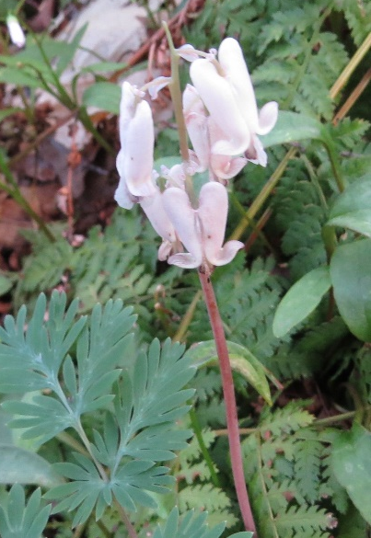
Squirrel corn in bloom
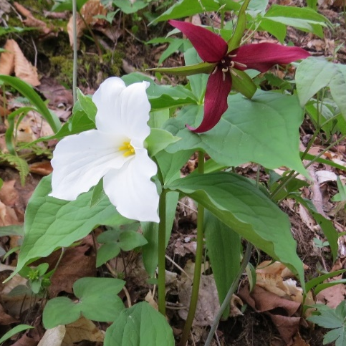
White Trillium and Purple Trillium

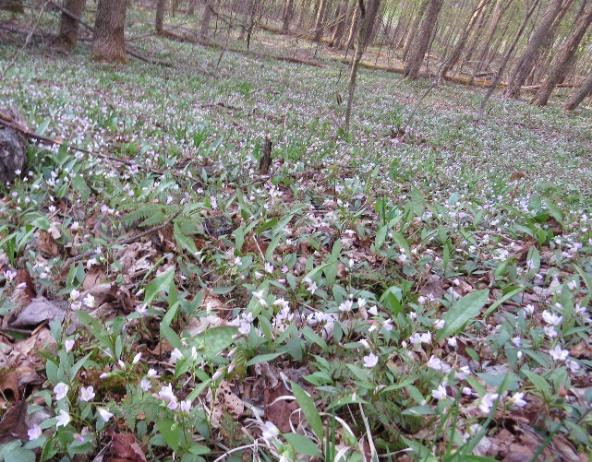
Millions of Spring beauties
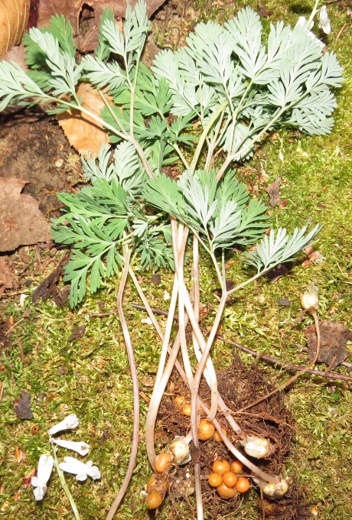
Squirrel corn and its root tubers
THESE SPRING WILDFLOWERS AND HUNDREDS MORE MAKE UP VITAL FOODS FOR DEER AND WILDLIFE IN PENNS WOODS

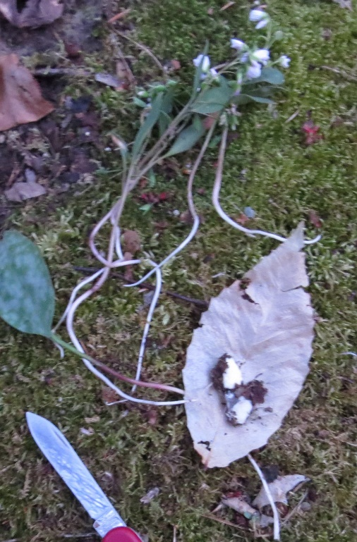
Tuber roots on spring beauties

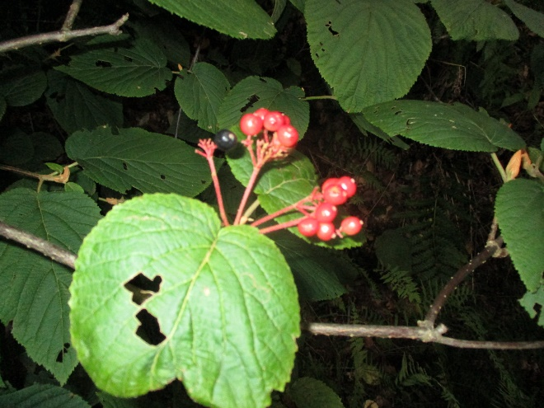
Hobblebush fruit

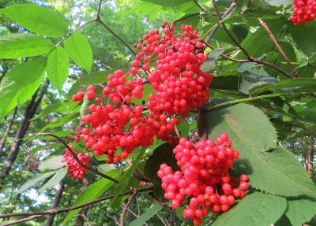
Red Berried Elder Fruit

SHADE TOLERANT SHRUBS LIKE THESE SHOULD BE FOUND BY THE THOUSANDS AND THOUSANDS THROUGHOUT THE KQDC. Others like alternate leafed dogwoods, American yews, rhododendrons, small hemlock seedlings and more should be much more plentiful than they are.

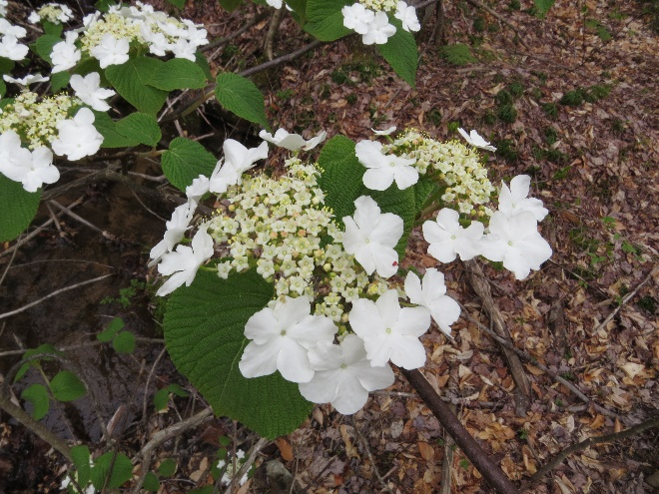
Hobblebush flowers in spring

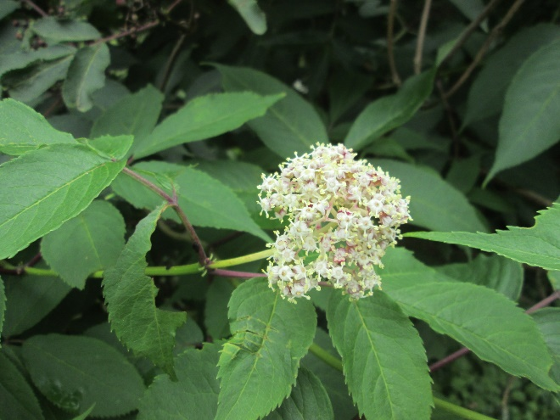
Red berried elder flowers in spring

